Lecture XIII
Non-steroidal antiinflummatry drugs
NSAIDs including aspirin and acetaminophen, two of the oldest pain medications, are among the most widely prescribed drugs worldwide for the treatment of rheumatic arthritis and other degenerative inflammatory joint diseases.126,127 Although NSAIDs are very effective in relieving mild to moderate pains and inflammation, their use is also often associated with many undesirable side effects, including GI irritation and bleeding, platelet dysfunction, kidney damage, and bronchospasm.126–129 With the exception of acetaminophen (Tylenol) and the newer “coxibs” drugs, the conventional NSAIDs (also commonly referred to as the aspirin-like drugs), share very similar therapeutic and side effect profiles. The conventional NSAIDs exert their therapeutic action by inhibiting two isoforms of cyclooxygenase (COX-1, the constitutive isozyme and COX-2, the inducible isozyme), which is the rate-limiting enzyme responsible for the biosynthesis of the proinflammatory prostaglandins (PGs) such as the PGD2, PGE2, PGF2, and PGI2 and thereby modulating pain transmission, attenuating inflammation, and reducing fever.127,128 They also produce their undesirable side effects such as GI bleeding, ulcerations, or renal impairments by blocking the same cyclooxygenases responsible for synthesizing PGs that modulate platelet activity (TXA2 and PGI2), gastric acid secretion and cytoprotection (PGE2 and PGI2), and renal blood flow (PGE2).128–132 In early 1990, Vane et al.133,134 hypothesized that the undesirable side effects of the conventional NSAIDs are a result of inhibition of the COX-1 isozyme, whereas the therapeutic effects are related mainly to their inhibitory action on the inducible COX-2 isozyme. This hypothesis has stimulated extensive drug development and hasty market introductions of many selective COX-2 inhibitors, or coxibs drugs.130,135 However, all of the marketed coxibs drugs except celecoxib (Celebrex), the first FDA-approved COX-2 drug in 1998, have been withdrawn from the market because of the potential risk of a cardiovascular event, including heart attack or stroke, especially in cardiac patients.136 Recent clinical trials have placed all NSAIDs under surveillance for their potential cardiovascular risk, thus the indiscriminate use of any NSAIDs including naproxen in cardiac patients should be avoided.135–137 Mechanism of Action and NSAID-Induced Side Effects For aspirin and many of the conventional NSAIDs, despite their worldwide use as pain medications for over a century, their mechanism of action was not completely known until 1971 when Vane first identified the cyclooxygenases as their molecular targets.128 Cyclooxygenase (also known as prostaglandin endoperoxide synthase or PGH synthase) is the rate-limiting enzyme responsible for the biosynthesis of PGs. PGs are short-lived, lipidlike molecules that play a vital role in modulating many important physiological and pathophysiological functions including pain, inflammation, gastric acid secretion, wound healing, and renal function. They are biosynthesized via a tissue-specific cyclooxygenase pathway (COX-1 or COX-2) either on an as-needed basis (mostly via the COX-1 isozyme) or via the induced and overexpressed COX-2 isozyme because of an injury, inflammation, or infection.126,129 Some of the salient features of the cyclooxygenase pathway involved in the biosynthesis of these PGs from arachidonic acid (AA) (5,8,11,14- eicosatetraenoic acid), a polyunsaturated fatty acid released from membrane phospholipids by the action of phospholipase A2, are depicted in Figure 24.14. As stated earlier, all classes of NSAIDs strongly inhibit prostaglandin synthesis in various tissues, especially at the site of the tissue damage or inflammation. This inhibition occurs at the stage of oxidative cyclization of AA, catalyzed by the rate-limiting enzyme, cyclooxygenase (or PGH synthase), to the hydroperoxy-endoperoxide (prostaglandin G2, PGG2) and its subsequent reduction to key intermediate, prostaglandin H2 (PGH2) needed for all prostaglandin biosynthesis.138 Blockade of PGH2 production, thus prevents its further conversion, by tissue-specific terminal prostaglandin synthases or isomerases, into different biologically active PGs
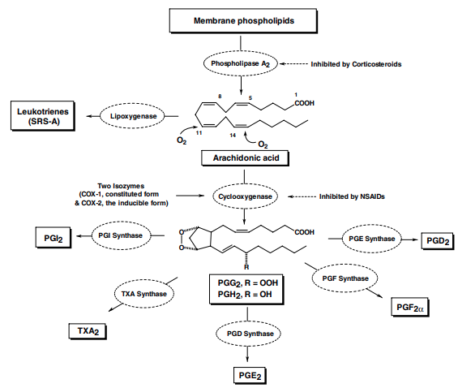
including PGE2, PGD2, PGF2, PGI2 (prostacyclin), and thromboxane A2 (TXA2) Among the PGs synthesized by the action of either COX1 or COX-2 isozymes, PGI2 and PGE2 made at the site of injury (via COX-2 isozyme in the inflammatory cells such as monocytes and macrophages) and also in the brain, are known to play a dominant role in mediating inflammation and inducing hyperanalgesia.132 However, their synthesis in the GI tract (via COX-1 isozyme) and in the renal tubules (via COX-1 and COX-2 isozymes), is essential to provide cytoprotective action for restoring the integrity of the stomach lining and maintaining renal functions in an otherwise compromised kidney as a result of constant insult.132,138 Thus, inhibition of PGE2 synthesis by the conventional NSAIDs in the parietal cells removes its ability to modulate histamine-mediated release of gastric acid from the parietal cells, whereas blockade of PGI2 and PGE2 synthesis in the epithelial cells in the stomach linings also prevents their action on the biosynthesis and release of bicarbonate and mucous gel desperately needed to repair damage resulting from erosion caused by gastric acid and other aggressive factors.127,129,132 Thus, it should not be surprising to note that NSAID-induced gastric ulcers can only be prevented clinically with coadministration of misoprostol, a stable PGE analog, but not with either the histamine H2-antagonists, sucralfate, or any proton pump inhibitors such as omeprazole.127 Furthermore, maintenance of kidney function, especially in patients with congestive heart failure, liver cirrhosis, or renal insufficiency, is reliant on the action of PGI2 and PGE2 to restore normal renal blood flow. Thus, NSAID use (both COX-1 and COX-2 inhibitors) will increase the risk of renal ischemia and therefore is contraindicated in these patients.129 The readers should consult Chapter 26 of this text on “Prostanglandins, Leukotrienes, and Other Eicosanoids” for a detailed discussion of PGs, their physiological and pathophysiological functions, and their corresponding PG receptors. Structure–Activity Relationships of NSAIDs It is well established that the therapeutic potency of the conventional NSAIDs are highly correlated with their ability to induce upper GI toxicity.127 But, are all NSAIDs other than coxibs really equally effective in the treatment of pain and inflammation? Some insight might be found by exploring how these chemically diverse classes of drugs bind to their molecular targets (i.e., their selectivity for COX-2 relative to COX-1).140 Thus, the benefit/risk profile of individual NSAIDs, as reflected by their COX selectivity, may be more clinically relevant for predicting the risk of GI complications. Table 24.1 summarizes a few representative drugs from different NSAID classes with their recommended daily
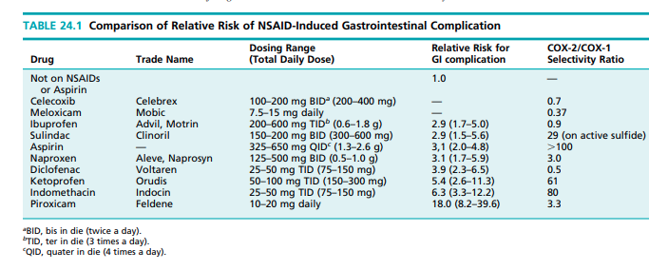
dosages and their relative risks of bleeding peptic ulcer complications.130,141,142 ENZYMATIC STRUCTURE OF CYCLOOXYGENASES Cyclooxygenases (COX-1 and COX-2) are heme-containing, membrane-bound proteins that share a high degree of sequence identity and also have very similar active site topography.138,143–145 Note that the homologous residues of the COX-2 isozyme are numbered in parallel with the similar amino acid residues found at the active site of COX-1 isozyme for easier comparison of their structural differences in the following discussion (i.e., the actual Arg-106 of human COX-2 [hCOX-2] is numbered as Arg-120).143 The actual hCOX-2 assignments for these residues are provided in parentheses. Thus, despite their similarity, the active site for hCOX2 is approximately 20% larger than the COX-1 binding site because of the replacement of Ile-523 in COX-1 with a smaller Val-523 in hCOX-2 (Val-509).138,144,145 There are a total of 24 amino acid residues lining the largely hydrophobic AA binding site with only one difference between the isozymes (i.e., Ile-523 in COX-1 and Val-509 in hCOX-2). The hCOX-2 isozyme has an additional hydrophilic side pocket accessible for drug binding, extended from the main binding pocket.143 The size and nature of this hydrophilic side pocket for binding in hCOX-2 is a result of further substitutions Ile-434 and His-513 in COX-1 with a smaller Val-434 (Val 420 in hCOX-2) and a more basic Arg-513 (Arg-499 in hCOX-2).146 Thus, it is not surprising that this basic amino acid residue in hCOX-2 (Arg-499) may provide an additional binding interaction for selective COX-2 inhibitors such as celecoxib.144 Although there is only a very limited amount of published data showing how the substrate, AA, binds to cyclooxygenases, the relative positioning of the double bonds in AA at the active site, proposed by Gund and Shen based on the conformational analysis of indomethacin and other conventional NSAIDs, is still currently valid.147 Interestingly, Arg-120 (Arg-104 in hCOX-2) is the only positively charged amino acid residue in the COX active site, on one end of the active site as depicted by Luong144,148 and is responsible for binding, via an ionic interaction, with the carboxylate anion of the substrate (AA) or the conventional NSAIDs. The amino acid residue Tyr-385 (Tyr-371 in hCOX-2) is located on the opposite end of the COX active site and is believed to serve as the catalytic residue for activating molecular oxygen and its initial addition to the 11-double bond of the substrate to form PGG2. 143–148 Furthermore, the presence of an amino acid residue, Ser-530 (Ser-516 in hCOX-2) is believed to be involved only in the irreversible inactivation by aspirin and NSAID action but not contributing to any substrate binding.143 BINDING OF NSAID TO CYCLOOXYGENASE Most NSAIDs possess a free carboxylic acid (COOH) for an ionic interaction with the positively charged arginine residue at the active site of the cyclooxygenases (i.e., Arg120 in COX-1 or Arg-106 in COX-2 isozymes). This acidic moiety is further linked to an aromatic (or heteroaromatic) ring for binding to either the 5 -double-bond or 8 -double-bond binding regions, and an additional center of lipophilicity in the form of an alkyl chain (e.g., ibuprofen) or an additional aromatic ring (e.g., indomethacin) for binding to the 11-double-bond binding region. A hypothetical binding model for indomethacin and related analogs to the COX-1 isozyme is shown in Figure 24. 15-A, based on the crystallographic and SAR data found in the literature.146,149 The suggested orientation and placement of the N-p-chlorobenzoyl group to the 11-doublebond binding region and the indole ring to the 5 - and 8 - double-bond binding regions is made from assuming that a preferred, lower-energy conformation of indomethacin is essential for its binding to COX isozymes147, and the fact that this orientation also allows correct positioning of the amide carbonyl oxygen for possible binding interactions to Ser-530 and the 5-methoxy group to Ser-355 at the active site of the enzymes.146 Additional support for this model can be obtained from the observation that the (Z)-isomer of sulindac, an indene isosteric analog of indomethacin, is much more potent than the corresponding (E)-isomer and the fact that replacement of the 5-methoxy group with a fluorine atom on the indole ring further enhances its analgesic action.145,149 Furthermore, because there is limited space available for binding around either Leu-384 or Ile-523 (i.e., both around the 11-double-bond binding region), it is not surprising to see a facile conversion of the indomethacin from a nonselective COX inhibitor into a potent and highly selective COX-2 inhibitor with just a simple substitution of the p-chlorine with a larger bromine atom or by addition of two chlorine atoms to the o,o’ positions of the N-p-chlorobenzoyl group reported by Kalgutkar et al.150 This observation can explain why a lower risk for GI complications was reported with sulindac than indomethacin, because it requires metabolic activation, via reduction of its bulky sulfoxide moiety into a much smaller methyl sulfide for binding into the Leu-384 pocket. The fact that kidneys possess a high level of the flavin-containing monooxygenases for deactivating the active metabolite of sulindac back into its inactive sulfoxide or sulfone, further provided evidence for this binding model.149,151 With this binding model, it is also possible to see why the relative therapeutic potency of the conventional NSAIDs and their ability to induce GI complication is in the order: indomethacin ketoprofen diclofenac naproxen ibuprofen. Ibuprofen is the least potent because it can only bind to the 5 -double-bond region with additional weak van der Waals interactions to the 11-double-bond region. Naproxen is slightly more active than ibuprofen, because its naphthalene ring, isosteric to the indole ring, can interact with both the 5 - and 8 -double-bond regions. Ketoprofen and diclofenac are slightly less potent than indomethacin because of the absence of an additional ring for binding to either the 5 - or the 8 -double-bond regions. BINDING OF CELECOXIB TO COX-2 ISOZYME The hypothetical binding model for binding of celecoxib, the only selective “coxibs” type COX-2 inhibitor shown on Figure 24.15B, is purely speculative, based only on the crystallographic binding data reported for SC-558 (the pbromophenyl analog of celecoxib) with the murine COX-2 isozyme.146 However, the celecoxib selectivity toward the COX-2 isozyme is most likely a result of the extension of the sulfonamide moiety into the extra hydrophilic-binding pocket, surrounded by His-90 (His-76 in hCOX-2) and Arg513 (Arg-499 in hCOX-2). The opening of this additional pocket for binding is the result of the replacement of Ile-523 in the COX-1 with a smaller valine residue (Val 509 in hCOX-2). It should be pointed out that a similar hydrophilic pocket does exist in the COX-1 isozyme, but it is inaccessible because of the bulkier Ile-523 residue that guards the entrance to this side pocket of the COX-1 isozyme (see Fig. 24.15-A). The COX-2/COX-1 selectivity ratios, estimated by different research groups, can be quite different (e.g., the reported selectivity ratio for celecoxib ranges any where from 0.003–0.7; for piroxicam, the range is 3.3–600). Thus, the selectivity ratios included in Table 24.1, obtained from one such study, is only valid for comparing their differences among these NSAIDs. Furthermore, recent reviews comparing the SAR among different structural classes of COX-2 inhibitors have indicated that there is little or no common pharmacophore required for their COX-2 selectivity, but minor changes within the structure type, in terms of molecular shape, lipophilicity, electronic density, flexibility, polarity, and hydrogen-bonding properties, can all have drastic effects in its COX selectivity.152,153 PIROXICAM AND MELOXICAM: THE DIFFERENCE IN THEIR COX SELECTIVITY Piroxicam and meloxicam have nearly identical structural features but also have at least a ninefold difference in selectivity for meloxicam to COX-2 isozyme and an even larger difference in their relative risks for GI complications (i.e., piroxicam has the highest risk among NSAIDs, whereas meloxicam has very little or no such side effects) (Table 24.1). A closer comparison of their structure (Fig. 24.16), however, reveals no apparent reason for these differences, either in size, lipophilicity, or electronic properties, between the 2-pyridyl group (in piroxicam) and the 5-methyl-2-thiazoyl group (meloxicam) that may alter their ability to bind COX isozymes. It is unlikely that these drastic differences in their COX selectivity, especially the drug-induced GI toxicity, could be due solely to the binding of the parent molecules with such minor changes in their structures. Thus, could the observed differences, especially the differences in drug-induced GI side effects, be attributed to the involvement of an active metabolite of piroxicam and/or meloxicam? The metabolism of piroxicam to its major active metabolite, 5-hydroxypiroxicam and meloxicam to its
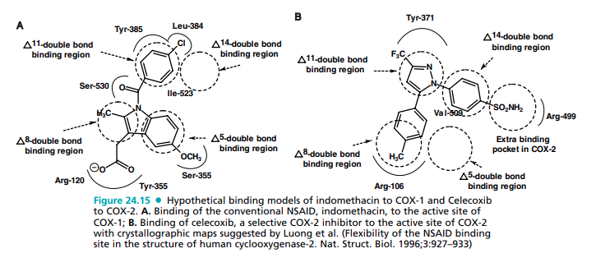
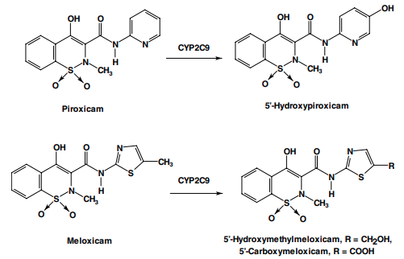
5-hydroxy-methylmeloxicam and 5-carboxymeloxicam metabolites are shown in Figure 24.16.154–156 Thus, with the proposed binding interaction of indomethacin described earlier (Fig. 24.15), it is reasonable to assume that the pyridyl group of the piroxicam or the 5-hydroxypyridyl group of its active metabolite will be directed to bind to the 11-double-bond binding region (especially the active metabolite caused by an additional H-bonding to the Tyr-385 residue), in a similar manner as the N-pchlorobenzoyl group of the indomethacin. This would also allow the OH group of the acidic enol carboxamide moiety of the piroxicam or its active metabolite to position itself for binding to the Ser-530 residue of the COX1 isozyme. However, a similar binding interaction of the active metabolites of meloxicam, especially the 5carboxy metabolite, to the active site of the COX-1 isozyme may not be possible, because it will reorient itself for a stronger ionic interaction with the Arg-120 of the COX-1 isozyme. Thus, they can fit only into the active site of the COX-2 isozyme because the binding of an acidic moiety to Arg-106 in the active site of the COX-2 isozyme is believed to play a lesser role in the inhibitory action of the COX-2 selective inhibitors like celecoxib152 (i.e., the most acidic moiety, sulfonamide is extended into the side pocket instead of binding to Arg-106). ASPIRIN AND ITS COX-1 SELECTIVITY Aspirin covalently modifies COX-1 and hCOX-2 isozymes by acetylating the OH group of Ser-530 in COX-1 and Ser516 in hCOX-2 isozymes. This is made possible by an ionic attraction between the carboxylate anion of aspirin and the arginine cation of Arg-120 in COX-1 (or Arg-106 in hCOX-2), thereby positioning the acetyl group of aspirin for acetylating the COX isozymes. Even though both COX isozymes are irreversibly acetylated by aspirin, acetylation of Ser-530 totally blocks the accessibility of substrate AA from entering into the active site, whereas an acetylated hCOX-2 is still able to form a significant amount of PGG2. 143 Thus, aspirin, among all conventional NSAIDs, exhibits the highest selectivity toward the COX-1 isozyme, especially the COX-1 isozyme present in the platelets. Aspirin and Salicylic Acid Derivatives Aspirin and the salicylates were among the first group of NSAIDs introduced into medicine for their use as analgesics to relieve pain and as antipyretics to reduce fever.157 As early as 1763, the Reverend Edward Stone of Chipping Norton in Oxfordshire, England reported the use of dried willow bark to parishioners suffering from rheumatic fever.129,158 The active ingredient of willow bark was isolated by Leroux, in 1827 and named salicin, which is a salicylic acid containing glycoside. After these discoveries, Cahours (1844) obtained salicylic acid from oil of wintergreen (methyl salicylate), and Kolbe and Lautermann (1860) prepared it synthetically from phenol. Sodium salicylate was introduced in 1875 by Buss, followed by the introduction of phenyl salicylate by Nencki in 1886. Aspirin, or acetylsalicylic acid, was first prepared in 1853 by Gerhardt but remained obscure until Felix Hoffmann from Bayer discovered its pharmacological activities in 1899. It was tested and introduced into medicine by Dreser (1899), who named it aspirin by taking the a from acetyl and spirin, an old name for salicylic or spiric acid, derived from its natural source of spirea plants. Most of the salicylic acid drugs (commonly referred to as the salicylates) are either marketed as salts of salicylic acid (sodium, magnesium, bismuth, choline, or triethanolamine) or as ester or amide derivatives (aspirin, salsalate, salicylamide). (Fig. 24.17) Children, between the ages of 3 and 12, who are recovering from flu or chicken pox, should not be taking aspirin or any salicylates because of the perceived risks of a rare disease known as Reye syndrome.159 MECHANISM OF ACTION OF SALICYLATES Salicylates, in general, exert their antipyretic action in febrile patients by increasing heat elimination of the body via the mobilization of water and consequent dilution of the blood.
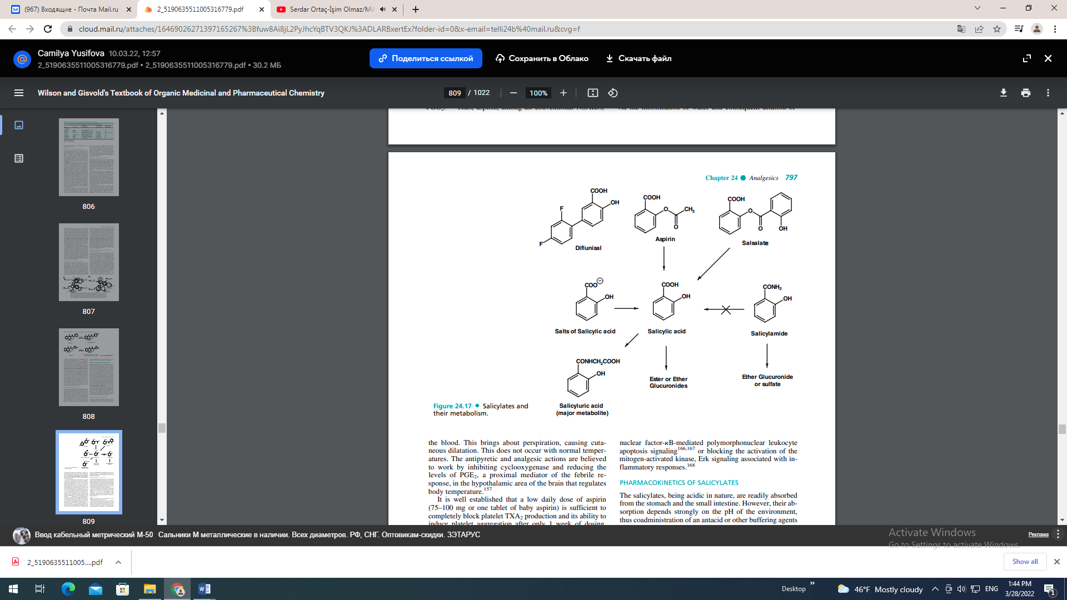
This brings about perspiration, causing cutaneous dilatation. This does not occur with normal temperatures. The antipyretic and analgesic actions are believed to work by inhibiting cyclooxygenase and reducing the levels of PGE2, a proximal mediator of the febrile response, in the hypothalamic area of the brain that regulates body temperature.157 It is well established that a low daily dose of aspirin (75–100 mg or one tablet of baby aspirin) is sufficient to completely block platelet TXA2 production and its ability to induce platelet aggregation after only 1 week of dosing, thereby preventing the risk of a cardiovascular event, including myocardial infarction and ischemic stroke.160,161 This antiplatelet action of aspirin is because COX-2 is not expressed in platelets; therefore, aspirin can selectively and irreversibly inhibit platelet TXA2 production for 8 to 10 days (i.e., until new platelets are formed) at such a low dose (i.e., via the irreversible acetylation of Ser-530 of the COX1 isozymes discussed earlier). However, the analgesic, antipyretic, and anti-inflammatory action of aspirin is more complex and may involve other mechanisms of action than simply based on its ability to irreversibly inhibit the COX isozymes.157,162,163 Furthermore, it is worth noting that up to 50% of the oral analgesic dose of aspirin is rapidly deacetylated before it reaches general circulation, and its major active metabolite, salicylic acid, is found to have comparable in vivo antipyretic and anti-inflammatory properties to aspirin but is a very weak inhibitor of cyclooxygenases (i.e., in vitro binding studies).164 Several possible mechanisms of action have recently been suggested for aspirin and especially the salicylates including blocking the induction of the COX-2 isozyme at the genetic levels,165 turning off the nuclear factor-B-mediated polymorphonuclear leukocyte apoptosis signaling166,167 or blocking the activation of the mitogen-activated kinase, Erk signaling associated with inflammatory responses.168 PHARMACOKINETICS OF SALICYLATES The salicylates, being acidic in nature, are readily absorbed from the stomach and the small intestine. However, their absorption depends strongly on the pH of the environment, thus coadministration of an antacid or other buffering agents should be avoided because it greatly hinders their absorption and reduces their bioavailability and onset of action. They are also highly bound to plasma proteins, a major source of potential drug interactions with other medications. Salicylic acid undergoes extensive phase-II metabolism (see Fig. 24.17) and is excreted via the kidneys as the watersoluble glycine conjugate, salicyluric acid, the major metabolite (75%) or as the corresponding acyl glucuronides (i.e., the ester type, via the COOH) or O-glucuronides (i.e., the ether type, via the phenolic OH) (15%). Alkalinization of the urine increases the rate of excretion of the free salicylates. Aspirin Aspirin, acetylsalicylic acid (Aspro, Empirin), was introduced into medicine by Dreser in 1899. Aspirin occurs as white crystals or as a white crystalline powder and must be kept under dry conditions. It is not advisable to keep aspirin products in the kitchen or bathroom cabinets, because aspirin is slowly decomposed into acetic and salicylic acids in the presence of heat and moisture. Several proprietaries (e.g., Bufferin) use compounds such as sodium bicarbonate, aluminum glycinate, sodium citrate, aluminum hydroxide, or magnesium trisilicate to counteract aspirin’s acidic property. One of the better antacids is dihydroxyaluminum aminoacetate. Aspirin is unusually effective when prescribed with calcium glutamate. The more stable, nonirritant calcium acetylsalicylate is formed, and the glutamate portion (glutamic acid) maintains a pH of 3.5 to 5. Practically all salts of aspirin, except those of aluminum and calcium, are unstable for pharmaceutical use. These salts appear to have fewer undesirable side effects and induce analgesia faster than aspirin. A timed release preparation of aspirin is available. It does not appear to offer any advantages over aspirin, except for bedtime dosage. Aspirin is used as an analgesic for minor aches and pains and as an antipyretic to reduce fever. Although higher doses of aspirin can also be used to treat inflammation, its use is often associated with many unwanted side effects including ulcers, stomach bleeding, and tinnitus. A low dosage form of aspirin, 81 mg, equivalent to the dose recommended for infants (the “baby aspirin”), is recommended as a daily dose for individuals who are at even a low cardiovascular risk. Several large studies have found that this low dose of aspirin reduces the number of heart attacks and thrombotic strokes.160,161 Other salicylates and NSAIDs have not shown similar effects. In fact, a recent report indicated using ibuprofen can interfere with aspirin’s cardiovascular benefits, and they should not be taken within 12 hours of each other.169 Aspirin and other potent NSAIDs (except salicylates) are also known to precipitate asthma attacks and other hypersensitivity reactions in up to 10% of the patients who have any type of respiratory problems.170 This hypersensitivity reaction is believed to occur as a result of shifting the substrate, AA from the inhibited cyclooxygenase pathway to the lipoxygenase pathway (see Fig. 24.14), therefore resulting in overproduction of anaphylactic leukotrienes because of the blockade of the cyclooxygenase pathway by aspirin and other potent NSAIDs.171 Salsalate Salsalate, salicylsalicylic acid (Amigesic, Disalcid, Salflex), is the ester formed between two salicylic acid molecules. It is rapidly hydrolyzed to salicylic acid following its absorption. It reportedly causes less gastric irritation than aspirin, because it is relatively insoluble in the stomach and is not absorbed until it reaches the small intestine. Diflunisal Diflunisal (Dolobid), is a longer acting and more potent drug than aspirin because of its hydrophobic, 2,4-difluorophenyl group attached to the 5-position of the salicyclic acid. In a large-scale comparative study with aspirin, it was also better tolerated with less GI complications than aspirin.172 It is marketed in tablet form for treating mild to moderate postoperative pain as well as RA and OA. Diflunisal is highly protein bound. Its metabolism is subject to a dose-dependent, saturable, and capacity-limited glucuronide formation.173 This unusual pharmacokinetic profile is a result of an enterohepatic circulation and the reabsorption of 65% of the drug and its glucuronides, followed by cleavage of its unstable, acyl glucuronide back to the active drug. Thus, diflunisal usage in patients with renal impairment should be closely monitored. Sodium Salicylate Sodium salicylate may be prepared by the reaction, in aqueous solution, by adding equal molar ratio of salicylic acid and sodium bicarbonate; evaporating to dryness yields the white salt. In solution, particularly in the presence of sodium bicarbonate, the salt will darken on standing. This is the salt of choice for salicylate medication and usually is administered with sodium bicarbonate to lessen gastric distress, or it is administered in enteric coated tablets. However, the use of sodium bicarbonate is ill advised, because it decreases the plasma levels of salicylate and increases the excretion of free salicylate in the urine. Sodium salicylate, even though not as potent as aspirin for pain relief, also has less GI irritation and is useful for patients who are hypersensitive to aspirin. OTHER SALTS OF SALICYLIC ACID Sodium thiosalicylate (Rexolate) is the sulfur or thio analog of sodium salicylate. It is more soluble and better absorbed, thus allowing lower dosages. It is recommended for gout, rheumatic fever, and muscular pains, but it is available only for injection. Magnesium salicylate (Mobidin, Magan) is a sodiumfree salicylate preparation for use when sodium intake is restricted. It is claimed to produce less GI irritation. Choline salicylate (Arthropan) is extremely soluble in water and is available as a flavored liquid. It is claimed to be absorbed more rapidly than aspirin, giving faster peak blood levels. It is used when salicylates are indicated. It is also available in combination with magnesium salicylate (Trilisate, Tricosal, Trisalcid, CMT) for the relief of minor to moderate pains and fever associated with arthritis, bursitis, tendinitis, menstrual cramps, and others. Salicylamide Salicylamide, o-hydroxybenzamide, is a derivative of salicylic acid that is fairly stable to heat, light, and moisture. It reportedly exerts a moderately quicker and deeper analgesic effect than aspirin because of quicker CNS penetration. Its metabolism differs from aspirin, because it is not metabolized to salicylic acid but rather excreted exclusively as the ether glucuronide or sulfate.174 Thus, as a result of lack of contribution from salicylic acid, it has a lower analgesic and antipyretic efficacy than that of aspirin. However, it can be used in place of salicylates for patients with a demonstrated sensitivity to salicylates. It is also excreted much more rapidly than other salicylates, which accounts for its lower toxicity. It is available in several nonprescription products, in combination with acetaminophen and phenyltoloxamine (e.g., Rid-A Pain compound, Cetazone T, Dolorex, Ed-Flex, Lobac) or with aspirin, acetaminophen, and caffeine (e.g., Saleto, BC Powder). The Conventional Nonselective Cyclooxygenase Inhibitors With the removal of rofecoxib (Vioxx) from the market and the concern of cardiovascular risk associated with celecoxib (Celebrex), the conventional NSAIDs, being more potent than aspirin and related salicylates, once again become the drug of choice for the treatment of RA and other inflammatory diseases.130 The conventional NSAIDs vary considerably in terms of their selective inhibitory action for COX-2 relative to COX-1 isozymes and also their relative drug-induced toxicities discussed earlier in this text. Although several drugs in this class are available OTC, they are no safer than prescription medications with regard to their drug-induced GI liability.127 The conventional NSAIDs, as a group, are highly protein bound and exhibit both pharmacokinetic as well as pharmacodynamic interactions with many drugs, especially anticoagulants, diuretics, lithium, and other arthritis medications. For the purpose of comparing their SAR, toxicity, and metabolic biotransformations, the conventional NSAIDs are further divided into several chemical classes. ARYL- AND HETEROARYLACETIC ACIDS This group of NSAIDs has received the most intensive attention for new clinical candidates. As a group, they show high analgesic potency in addition to their potent antiinflammatory activity, needed for treating inflammatory diseases. Among the members of this class shown in Figure 24.18, ketorolac, indomethacin, and tolmetin have the highest risk of GI complications because of their higher affinity for the COX-1 isozymes, whereas etodolac has the lowest risk because of its COX-2 selective inhibitory action. Both sulindac and nabumetone are prodrugs that require activation, and therefore have lower risk of causing GI irritation than indomethacin.130 Indomethacin From the time of its introduction in 1965, indomethacin (Indocin) has been widely used as an analgesic to relieve inflammatory pain associated with RA, OA and ankylosing spondylitis, and, to a lesser extent, in gout. Although both its analgesic and anti-inflammatory activities are well established, its use is often limited because of frequent GI distress and potential drug interactions, especially with warfarin furosemide, and lithium (i.e., it elevates blood levels of lithium as a result of reducing renal blood flow and therefore increases lithium toxicities). Following oral administration, indomethacin is rapidly absorbed and is 90% protein bound at therapeutic plasma concentrations.175 The drug has a biological half-life of about 5 to 10 hours and a plasma clearance of 1 to 2.5 ml/kg per minute. It is metabolized to its inactive, O-desmethyl, N-deschlorobenzoyl-, and O-desmethyl, N-deschlorobenzoylindomethacin metabolites.175 Sulindac Sulindac, (Z)-5-fluoro-2-methyl-1-([p-(methylsulfinyl) phenyl]methylene)-1H-indene-3-acetic acid (Clinoril), is an NSAID prodrug that contains a chiral sulfoxide moiety but is marketed as the racemate because it undergoes in vivo reduction by the hepatic enzymes into its achiral, active metabolite, methyl sulfide that exhibits potent and nonselective COX inhibition similar to indomethacin.151 The parent sulfoxide has a plasma half-life of 8 hours, and the active methyl sulfide metabolite is 16.4 hours. The more polar and inactive sulfoxide is virtually the only form excreted into the renal tubules, thus sulindac is believed to have minimal nephrotoxicity associated with indomethacin.176 The long half-life of sulindac is caused by the extensive enterohepatic circulation and reactivation of the inactive sulfoxide excreted. Coadministration of aspirin is contraindicated because it considerably reduces the sulfide blood levels. Careful monitoring of patients with a history of ulcers is recommended. Gastric bleeding, nausea, diarrhea, dizziness, and other adverse effects have been noted with sulindac, but with a lower frequency than with aspirin. Sulindac is recommended for RA, OA, and ankylosing spondylitis. Tolmetin Tolmetin sodium (Tolectin), is an arylacetic acid derivative with a pyrrole as the aryl group. This drug is well absorbed and has a relatively short plasma half-life (1 hour). It is recommended for use in the management of acute and chronic RA.
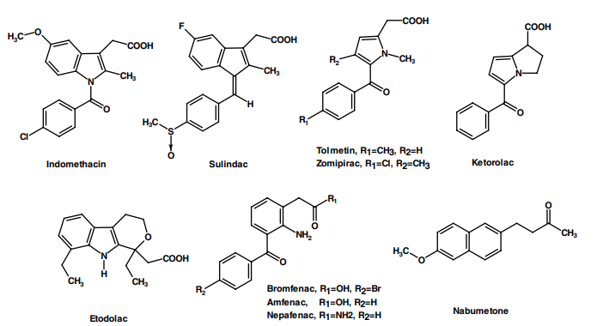
Its efficacy is similar to aspirin and indomethacin, but with less frequency of the adverse effects and tinnitus associated with aspirin. It does not potentiate coumarin-like drugs nor alter the blood levels of sulfonylureas or insulin. However, tolmetin, and especially its closely related drug, zomepirac (i.e., with a p-chlorobenzoyl group and an additional methyl group on the pyrrole ring), can produce a rare but fatal anaphylactic reaction because of irreversible binding of their unstable acyl glucuronides.177 Zomepirac was withdrawn from market because it is eliminated only via the ester-type, acyl glucuronide.178 It is possible that tolmetin is less toxic in this regard because it undergoes additional hepatic benzylic hydroxylation via its p-methyl group and is excreted as its stable ether glucuronide. Ketorolac Ketorolac tromethamine (Toradol), marketed as a mixture of (R)- and (S)-ketorolac enantiomers, is a potent NSAID analgesic indicated for the treatment of moderately severe, acute pain. It should be noted that the pharmacokinetic disposition of ketorolac in humans is subject to marked enantioselectivity. Thus, it is important to monitor the individual blood levels so an accurate assessment of its therapeutic action can be made correctly.179 However, it should be noted that, being one of the conventional NSAIDs with highest risk of GI complications, its administration should not exceed 5 days. Nabumetone Nabumetone (Relafen), a nonacidic NSAID prodrug, is classified as an arylacetic acid, because it undergoes rapid hepatic metabolism to its active metabolite, 6-methoxy-2- naphthylacetic acid.180 Similar to the other arylacetic acid drugs, it is used in short- or long-term management of RA and OA. Being nonacidic, it does not produce significant primary insult to the GI mucosa lining and also has no effect on prostaglandin synthesis in gastric mucosa, thus producing minimum secondary GI damage when compared with other conventional NSAIDs. Etodolac Etodolac (Lodine, Ultradol), a chiral, COX-2 selective NSAID drug that is marketed as a racemate, possesses an indole ring as the aryl portion of this group of NSAID drugs. It shares many similar properties of this group and is indicated for short- and long-term management of pain and OA. Similar to ketorolac, etodolac exhibits several unique enantioselective pharmacokinetic properties.181 For example, the “inactive” (R)-enantiomer has approximately a 10-fold higher plasma concentration than the active (S)-enantiomer. Furthermore, the active (S)-enantiomer is less protein bound than its (R)-enantiomer and therefore has a very large volume of distribution. It is well absorbed with an elimination halflife of 6 to 8 hours. Etodolac is extensively metabolized into three major inactive metabolites, 6-hydroxy etodolac (via aromatic hydroxylation), 7-hydroxy-etodolac (via aromatic hydroxylation), and 8-(1-hydroxylethyl) etodolac (via benzylic hydroxylation), which are eliminated as the corresponding ether glucuronides.182 Its unstable, acyl glucuronide, however, is subject to enterohepatic circulation and reactivation to the parent drug, similar to other NSAIDS in this class. In a recent study comparing its gastric safety profile with those of meloxicam, diclofenac, and indomethacin, etodolac was found to have the highest safety index among these NSAIDs in arthritic rats.183 Thus, etodolac is an example of a COX-2 selective drug with a much better safety profile among the first generation of NSAIDs developed through the traditional route of using only animal model studies. Its selective COX-2 inhibitory action, which was not realized until much later, explains its much lower risk of the GI side effects among first-generation NSAIDs. Amfenac, Bromfenac, and Nepafenac Amfenac (Fenazox), its amide prodrug, nepafenac (Nevanac), and the related analog, bromofenac, are amphoteric because of the presence of an additional aromatic amine group. They are less likely to be absorbed into the general circulation. They are approved for use as topical ocular anti-inflammatory agents for the treatment of postoperative ocular pain, inflammation, and posterior segment edema.184 The only observed side effects of these drugs are all related to tissues around the eye including abnormal ocular sensation, eye redness and irritation, burning and stinging, and conjunctival or cornea edema. ARYL- AND HETEROARYLPROPANOIC ACIDS These are perhaps the most widely used drugs worldwide because three members of this class, ibuprofen, naproxen, and ketoprofen, are now available without a prescription (Fig. 24.19). Their indiscriminate use, however, by the general public without a doctor’s prescription, has resulted in an increased incidence of complications in adolescents, including acute and chronic renal failure.185 All of the members of this class (except oxaprozin) contain a chiral carbon in the -position of the acetic acid side chain. Even though most are marketed as racemates, only the (S)-enantiomer was found to have any inhibitory activity against the COX isozymes. Thus, the (S)-enantiomer is believed to be solely responsible for the observed therapeutic action as well as the drug-induced GI side effects and nephrotoxicity. Furthermore, in most cases, the inactive (R)- enantiomer is epimerized in vivo, via the 2-arylpropionyl coenzyme-A epimerase to its active (S)-enantiomer.186 Ibuprofen Ibuprofen, 2-(4-isobutylphenyl)propionic acid (Motrin, Advil, Nuprin), was introduced into clinical practice following extensive clinical trials. It appears to have comparable efficacy to aspirin in the treatment of RA, but with a lower incidence of side effects. It has also been approved for use in the treatment of primary dysmenorrhea, which is thought to be caused by an excessive concentration of PGs and endoperoxides.187 However, a recent study indicates that concurrent use of ibuprofen and aspirin may actually interfere with the cardioprotective effects of aspirin, at least in patients with established cardiovascular disease.169 This is because ibuprofen can reversibly bind to the platelet COX-1 isozymes, thereby blocking aspirin’s ability to inhibit TXA2 synthesis in platelets. Naproxen Naproxen (Naprosyn, Anaprox), marketed as the (S)-enantiomer, is well absorbed after oral administration, giving peak plasma levels in 2 to 4 hours and a half-life of 13 hours. Naproxen is highly protein bound and displaces most protein-bound drugs. It is recommended for use in RA, OA, acute gouty inflammation, and in primary dysmenorrhea. It shows good analgesic activity (i.e., 400 mg is comparable to 75–150 mg of oral meperidine and superior to 65 mg of propoxyphene and 325 mg of aspirin plus 30 mg of codeine).
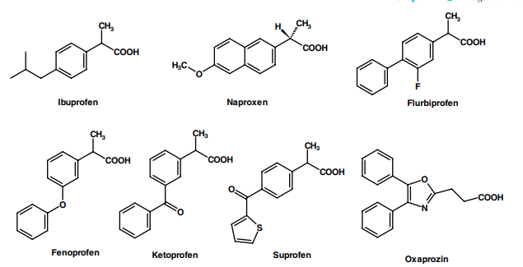
It is also available OTC as 200-mg tablets (Aleve). Fenoprofen Fenoprofen (Nalfon), is rapidly absorbed orally, reaches peak plasma levels within 2 hours, and has a short plasma half-life (3 hours). It is highly protein bound, just like the other NSAIDs, thus caution is needed when it is used concurrently with other medications including hydantoins, sulfonamides, and sulfonylureas. It is recommended for RA and OA, at an oral dose of 300 to 600 mg for 3 or 4 times per day, but not exceeding 3 g/d to avoid any serious side effects. It should be noted that in a comparison study of all NSAIDs, fenoprofen is the one that has been most closely associated with a rare acute interstitial nephritis.188 For mild to moderate pain relief, the recommended dosage is 200 mg given every 4 to 6 hours, as needed. Ketoprofen and Suprofen Ketoprofen (Orudis, Rhodis) and suprofen (Profenal) are closely related to fenoprofen in their structures, properties, and indications. Even though ketoprofen has been approved for OTC use (Orudis KT, Actron), its GI side effects are similar to indomethacin (Table 24.1), and therefore its use should be closely monitored, especially in patients with GI or renal problems. Flurbiprofen Flurbiprofen (Ansaid, Ocufen, Froben), is another drug in this class indicated for both acute and long-term management of RA and OA but with a more complex mechanism of action. Unlike the other drugs in this class, it does not undergo chiral inversion (i.e., the conversion of the “inactive” [R]-enantiomer to the active, [S]-enantiomer). Similar to aspirin and other salicylates, both flurbiprofen enantiomers block COX-2 induction as well as inhibiting the nuclear factor-B-mediated polymorphonuclear leukocyte apoptosis signaling189; therefore, both enantiomers are believed to contribute equally to its overall anti-inflammatory action. (R)-flurbiprofen is actually a strong clinical candidate for the treatment of Alzheimer disease, because it has been shown to reduce A42 production by human cells.190 Oxaprozin Oxaprozin, 4,5-diphenyl-2-oxazolepropionic acid (Daypro), differs from the other members of this group in being an arylpropionic acid derivative. It shares the same properties and side effects of other members in this group. It is indicated for the short- and long-term management of OA and RA, administered as a once-daily dose of 600- to 1,200-mg dose because of its long duration of action.191 N-ARYLANTHRANILIC ACIDS (FENAMATES) AND STRUCTURALLY RELATED ANALOGS This class of NSAIDs shares one common structural feature that is not present in the other classes discussed earlier. Unlike other classes discussed earlier, the second aromatic ring in this class is connected to the main aromatic carboxylic acid containing ring through a secondary amine linkage (rather than carbonyl group or other nonbasic linker) and at the ortho position rather than at the meta or para position (see their structures in Fig. 24.20). As a result of this structural feature, this class of NSAIDs appears to have a lower risk of causing GI irritation. Recent crystallographic evidence suggests that diclofenac binds to COX isozymes in an inverted conformation with its carboxylate group hydrogen-bonded to Tyr-385 and Ser-530.192 This finding provides a reason why diclofenac and especially its related analog, lumicoxib, have much greater selectivity toward COX-2 isozymes. Mefenamic Acid Mefenamic acid (Ponstel, Ponstan) is one of the oldest NSAIDs, introduced into the market in 1967 for mild to moderate pain and for primary dysmenorrhea. It is rapidly bsorbed with peak plasma levels occurring 2 to 4 hours after oral administration.
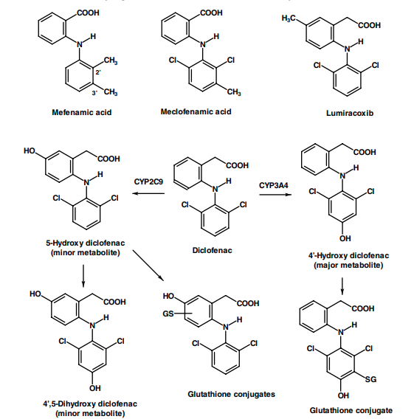
It undergoes hepatic benzylic hydroxylation of its 3methyl group regioselectively into two inactive metabolites, 3-hydroxymethylmefenamic acid and the 3carboxylate metabolite (via further oxidation of the benzylic alcohol group). The parent drugs and these metabolites are conjugated with glucuronic acid and excreted primarily in the urine. Thus, although patients with known liver deficiency may be given lower doses, it is contraindicated in patients with preexisting renal dysfunction. Common side effects associated with its use include diarrhea, drowsiness, and headache. The possibility of blood disorders has also prompted limitation of its administration to 7 days. It is not recommended for children or during pregnancy. Meclofenamate Meclofenamate sodium (Meclomen) is available for use in the treatment of acute and chronic RA, OA, and primary dysmenorrhea. It is metabolized in a similar manner to mefenamic acid discussed above, thus a similar restriction is also applied to meclofenamate. The most significant side effects are GI, including diarrhea. Diclofenac and Lumiracoxib Diclofenac sodium (Voltaren), is indicated for short- and longterm treatment of RA, OA, and ankylosing spondylitis. The potassium salt (Cataflam), which is faster acting, is indicated for the management of acute pain and primary dysmenorrhea. Diclofenac was first marketed in Japan in 1974 but was not approved for its use in the United States until 1989, perhaps because of concerns about its hepatotoxicity. Diclofenac is also available in combination with misoprostol (Arthrotec). Unlike the other NSAIDs, diclofenac appears to be more hepatotoxic and, in rare cases, can cause severe liver damage. This idiosyncratic hepatotoxicity has been attributed to the formation of reactive benzoquinone imines, similar to acetaminophen, which will be discussed later.193 Diclofenac undergoes hepatic CYP2C9/3A4 catalyzed aromatic hydroxylations to give 4-Hydroxy-diclofenac as its major inactive metabolite (30%) and 5-hydroxy- and 45-dihydroxy-diclofenac as its minor metabolites (Fig. 24.20). These hydroxylated metabolites are excreted, normally, such as their glucuronides. Similar to that of acetaminophen, both the 4and 5-hydroxylated metabolites can be further activated to their reactive quinone imines (not shown in the Figure), which are normally deactivated by glutathione, the host defensive mechanism, to its inactive glutathione conjugates shown in Figure 24.20. Thus, it is reasonable to assume that patients with low levels of glutathione are more susceptible to diclofenac toxicity, and their use in these patients should be avoided. Lumiracoxib (Prexige), one of the most COX-2 selective inhibitors marketed in Australia (2004), the United Kingdom (2005), and the United States (2007), was the mainstay of therapy for OA, RA, and acute pain. It differs from diclofenac with an additional methyl substituted onto the 5-position of phenylacetic acid ring. It is extensively metabolized by CYP2C9, just like diclofenac, into three major inactive metabolites, 5-carboxy, 4-hydroxy, and 4-hydroxy-5-carboxy derivative, through the oxidation of the 5-methyl group and hydroxylation of the dichloroaromatic ring.194 Although no evidence of formation of potentially reactive metabolites was reported, the 4-hydroxy derivatives are the major inactive metabolites eliminated (as the glucuronides), so it is not surprising to learn that lumiracoxib was withdrawn from market in October, 2007 because of several cases of serious adverse liver reactions to the drug, including two deaths and two liver transplants. Thus, patients with low glutathione levels or glucuronyl transferase activity as a result of drug interactions or aging are susceptible for forming reactive metabolites that are not found with healthy individuals, the subjects used in the original metabolic study.194 OXICAMS Oxicams, are first-generation NSAIDs that lack a free carboxylic acid side chain but with an acidic enolic 1,2-benzothiazine carboxamide ring (see Fig. 24.16). Only two members of this class, piroxicam and meloxicam, are available in the United States for the management of inflammatory arthritis. Tenoxicam (Mobiflex), a close isosteric analog of piroxicam (i.e., with a 1,2-thiazole ring replacing the benzene ring fused to the thiazine ring), is available in Canada but with a pharmacodynamic and pharmacokinetic profile similar to piroxicam. As discussed earlier, piroxicam and meloxicam have very different affinities for the COX isozymes, and therefore exhibit very different risks for GI complications. Piroxicam Piroxicam (Feldene) is the most widely used oxicam because of its once-daily dosing schedule. It is well absorbed after oral administration and has a plasma half-life of 50 hours, thus requiring a dose of only 20 to 30 mg once daily.195 It undergoes extensive hepatic metabolism, catalyzed by CYP2C9 to give 5-hydroxypiroxicam as its major metabolite (See Fig. 24.16).154 Several piroxicam prodrugs have been synthesized via derivatization of the enol alcohol group (amipiroxicam, droxicam, and pivoxicam) to reduce piroxicam-induced GI irritation.195 Meloxicam Meloxicam (Mobic) is a selective COX-2 inhibitor among oxicams indicated for use in RA and OA. It also has a relatively long half-life of 15 to 20 hours and has a much lower rate of serious GI side effects and a lower than average risk of nephropathy when compared with other conventional NSAIDs.196 The recommended dose is 7.5 mg once daily with a maximum of 15 mg/d. Meloxicam is metabolized in humans mainly by CYP2C9 (with a minor contribution via CYP3A4) to 5-hydroxymethylmeloxicam and 5carboxymeloxicam (see Fig. 24.16).156 In large-scale comparative trials, meloxicam was found to be at least as effective as most conventional NSAIDs in the treatment of rheumatic disease or postoperative pain, but has demonstrated a more favorable GI tolerability profile.158 The Selective COX-2 Inhibitors As stated earlier, the development and hasty market introduction of the first selective coxibs drugs, celecoxib (Celebrex), and rofecoxib (Vioxx) in 1999, was based on Vane’s133,134 hypothesis that blocking an inducible COX-2 isozyme retains all of the therapeutic effects but none of the side effects of the conventional NSAIDs. Shortly after their market introduction, the results of a preliminary Vioxx gastrointestinal outcomes research (VIGOR) trial was reported in 2000 that raised concern and much debate on the cardiovascular safety of all selective COX-2 inhibitors.135–137,197 Several additional coxibs drugs including valdecoxib (Bextra), etoricoxib (Arcoxia), and parecoxib sodium (Dynastat), were introduced into the worldwide market during 2002. The potential cardiovascular risk was not taken seriously until late 2004 when rofecoxib (Vioxx) was voluntary withdrawn from the worldwide market, based on an additional risk assessment from a 3-year randomized, placebo-controlled, double-blind clinical trial.197 To date, all but the least potent of COX-2 drugs, celecoxib (Celebrex), have been removed from the worldwide market, therefore depriving an otherwise, rational choice of pain medications, especially for arthritic patients who are at higher risk of serious GI complications.137 An overexpression of COX-2 was found in multiple cancer types, especially in colorectal cancer,198,199 thus future roles of the selective COX-2 inhibitors may be realized in the chemoprevention of cancers and other inflammatory degenerative diseases. The reader should consult several excellent reviews on these latest developments.200–202 CELECOXIB Celecoxib (Celebrex) was the first selective COX-2 inhibitor drug introduced into the market in 1998 for use in the treatment of RA, OA, acute pain, and menstrual pain. The real benefit is that it has caused fewer GI complications when compared with other conventional NSAIDs. It has also been approved for reducing the number of adenomatous colorectal polyps in familial adenomatous polyposis (FAP). Celecoxib is well absorbed and undergoes rapid oxidative metabolism via CYP2C9 to give its inactive metabolites (Fig. 24.21).203 Thus, a potential drug interaction exists between celecoxib and warfarin because the active isomer of warfarin is primarily degraded by CYP2C9. The Analgesic Antipyretics: Acetaminophen (Paracetamol) and Related Analogs From a historical perspective, acetaminophen (paracetamol) and the related analgesic antipyretic drugs such as acetanilide, antipyrine, and dipyrone were introduced into the market about the same time as aspirin and the other salicylates (i.e., acetanilide, 1886; phenacetin, 1887; and acetaminophen, 1893).204 They were once the most widely used analgesic antipyretics for relieving pain and reducing fever because, unlike aspirin and salicylates, they do not cause ulceration or increase bleeding time.
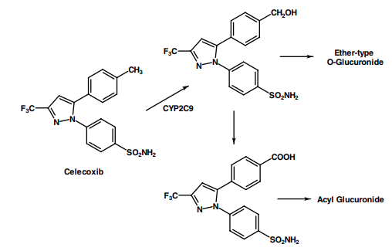
Among these agents, phenacetin was once a very popular analgesic antipyretic drug, more so than acetaminophen, because it was perceived to be safer than acetaminophen toward the stomach (i.e., less acidic in nature). Its use was continued until the late 1970s, even though Brodie and Axelrod had already reported in 1949 that acetaminophen was the active metabolite of acetanilide and phenacetin.205 In their elegant studies, acetanilide was found to undergo hepatic metabolism (i.e., via an aromatic hydroxylation) to acetaminophen, whereas only a small amount of the drug was hydrolyzed to give aniline, which can be further N-hydroxylated to phenylhydroxylamine, the compound believed to be responsible for acetanilide toxicity because of methemoglobin formation. Phenacetin, on the other hand, was found to undergo mostly O-dealkylation to acetaminophen, whereas a small amount was converted by deacetylation to p-phenetidine, also responsible for methemoglobin formation. Phenacetin only fell out of favor around 1980 when it was found to cause renal and urinary tract tumors in experimental animal models.206 Because of the toxicity described above, both acetanilide and phenacetin are now no longer available, thus acetaminophen is the only drug in this class that is still widely used worldwide because it is a safer and better tolerated pain medication. MECHANISM OF ACTION: ACETAMINOPHEN AND THE COX-3 PUZZLE Acetaminophen and other analgesic antipyretics have similar analgesic and antipyretic efficacies to the conventional NSAIDs such as aspirin, ibuprofen, or diclofenac. However, unlike the conventional NSAIDs, they lack the antiplatelet effects of aspirin or the GI side effects associated with NSAIDs. Acetaminophen also has little or no anti-inflammatory properties.207–209 Although it has been in use for nearly a century, the mechanism of action of acetaminophen and related analgesic antipyretics remains unknown, but it is generally assumed that they work centrally by blocking a brain-specific enzyme, perhaps a COX-3 isozyme, responsible for the biosynthesis of prostaglandin.210 In 2002, Simmons et al.,211 through cloning studies, identified a distinct variant of the canine COX-1 isozyme found only in the canine brain, which was designated as the COX3 isozyme and hypothesized this isozyme as the target for acetaminophen and related analgesic-antipyretic drugs because this isozyme was selectively inhibited by acetaminophen, phenacetin, antipyrine, and dipyrone. This hypothesis was further supported by the findings that acetaminophen produces analgesia and induces hypothermia centrally and that both of these actions are accompanied by a dose-dependent reduction of brain PGE2 levels that is not observed with diclofenac, a conventional NSAID.209 In addition, the peripheral levels of PGE2/PGI2 levels were reduced only by diclofenac but not by acetaminophen.210 Moreover, acetaminophen-induced hypothermia was reduced in COX-1 but not COX-2 gene-deleted animal studies.209,212 These observations appear to provide additional support for hypothesis that the analgesia and hypothermia of acetaminophen are indeed mediated by inhibition of a distinct COX isozyme present only in the brain. However, most of the recent studies focusing on finding this elusive human COX-3 isozyme have not been successful.207,213,214 Moreover, a similar COX1 variant identified and expressed in humans (this isozyme was designated as COX-1b) was not inhibited by acetaminophen even though it is active in catalyzing PGH2 synthesis in the brain. Thus, although the COX-3 isozyme may indeed be the molecular target responsible for acetaminophen action in canines, its role in humans is still unproven.213,214 In a recent commentary, Aronoff et al.208 suggested an alternative target (mechanism) by which acetaminophen (APAP) blocks the cyclooxygenase action. Their hypothesis is based on the fact that acetaminophen acts as a reducing cosubstrate, thus actively competing with PGG2 for its conversion to PGH2, catalyzed by the peroxidase (POX) action of COX enzymes. Figure 24.22 summarizes some of the key mechanism of COX’s action suggested by Aronoff et al.208 and includes the additional hypothesis suggested by Gram and Scott215 that acetaminophen acts by depleting the stores
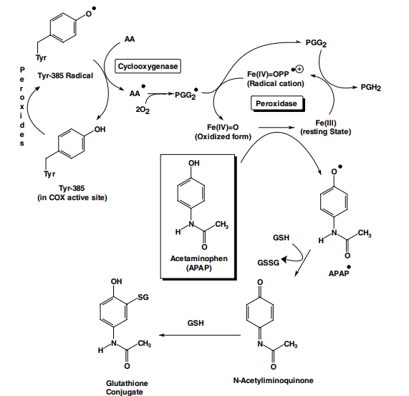
of glutathione (GSH), which is a known cofactor for PGE synthase. Thus, with this illustration, it is now possible to see why acetaminophen’s action depends on the level of peroxide generated in solution (i.e., PGG2 and other lipid peroxides, generated by the lipoxygenase pathway), and its effectiveness varies with COX activity.207 At low peroxide concentrations, acetaminophen can compete effectively with the electron transfer mechanism between the Tyr-385 residue and the heme radical, which generates the tyrosine radical in the active site of COX enzymes for the production of PGG2, it also prevents the regeneration of Fe (IV) (APAP causes the formation of Fe (III), thus ↓ activity of POX), a process that is essential for starting a new POX cycle as shown in Fig. 24.22. However, acetaminophen is ineffective during inflammation because the higher concentration of PGG2 or other peroxides, produced in the inflamed cells as a consequence of induction of the COX-2 isozyme and lipoxygenase, can overcome the acetaminophen inhibition by degrading acetaminophen in the synovial fluids as depicted in Figure 24.22 (i.e., conversion of APAP to its inactive glutathione conjugate shown). This mechanism would also explain the recent findings that acetaminophen, unlike NSAIDs, cannot inhibit COX activity in broken cells, and the observation that only the inhibitory effects of acetaminophen, not indomethacin or diclofenac, were abolished by increasing intracellular oxidation conditions with the addition of cell-permeable hydroperoxide, t-butyl-OOH.216 This hypothesis would also provide an additional reason why depletion of glutathione is the main cause of acetaminophen toxicity discussed under the next section. In summary, APAP does not compete with AA for the binding site on the COX enzyme. Its mechanism of action is via inhibiting the peroxidase activity of the COX enzyme. TOXICITY IN ACETAMINOPHEN AND PHENACETIN Acetaminophen and phenacetin can be metabolized to reactive hepatotoxic and renal toxic metabolites by various mechanisms.217 Readers should consult a more detailed discussion in the drug metabolism chapter of this text. Figure 24.23 summarizes only the salient features for the purpose of discussing phenacetin/acetaminophen-induced liver and renal toxicities. Acetanilide and phenacetin are hydroxylated or Odealkylated, respectively via CYP1A2 to their active metabolite, acetaminophen.206 In healthy individuals, acetaminophen is primarily eliminated as its O-sulfates and O-glucuronides, with only a small amount of the
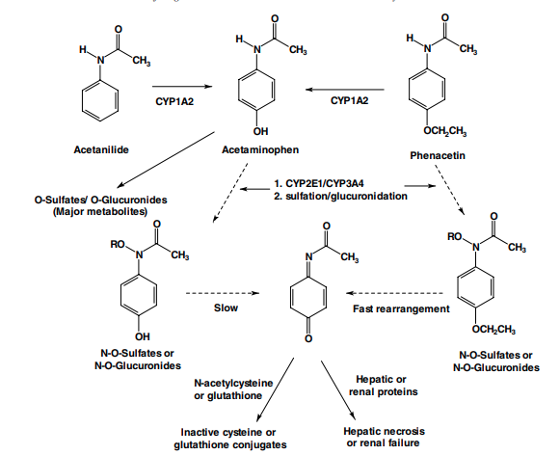
N-hydroxylated metabolite (via CYP2E1/CYP3A4 isozymes), which can be sulfated or glucuronidated.217,218 Small amounts of these O-sulfates, if accumulated in liver or renal tubules, can slowly rearrange to form the reactive Nacetyliminoquinone metabolites, shown in Figure 24.23. However, these reactive metabolites, once formed, are immediately deactivated by glutathione, the body’s defense mechanism for detoxifying reactive metabolites. In contrast, a similar N-O-sulfate of phenacetin will immediately rearrange to this reactive metabolite, N-acetyliminoquinone, whereas the corresponding N-O-glucuronide can also be slowly converted to this reactive metabolite.217 Thus, it is not surprising that acetaminophen is a much safer drug than phenacetin with regard to their relative toxicities (i.e., with occasional use, most of acetaminophen is eliminated as its O-sulfates and O-glucuronides). However, it should be pointed out that acetaminophen-induced toxicity can be greatly increased by concurrent use of alcoholic beverages, especially in alcoholic individuals. This is because both CYP2E1 and CYP3A4 isozymes are induced by alcohol consumption.218 Moreover, heavy caffeine use, together with alcohol, would further increase the risk of alcohol-mediated acetaminophen hepatotoxicity.219 Nacetylcysteine is typically given as an antidote to treat possible acetaminophen poisoning even before plasma levels of acetaminophen are determined. Similar to glutathione, it deactivates the N-acetyliminoquinone metabolite before it changes to covalently bind cellular proteins (Fig. 24.23). ACETAMINOPHEN Acetaminophen (also known as paracetamol, APAP), a well established analgesic/antipyretic drug, is frequently used by itself OTC (Panado, Tempra, Tylenol) or in combination with codeine (Tylenol 3), hydrocodone (Vicodin), or oxycodone (Percocet) for the treatment of mild to moderate pain and to reduce fever. It is available in several nonprescription forms and is also marketed in combination with aspirin and caffeine (Excedrin, Vanquish). Unlike aspirin or ibuprofen, acetaminophen is well tolerated with a low incidence of GI side effects. It also has good oral bioavailability, a fast onset and a plasma half-life of approximately 2 hours after dosing. Although it is a relatively safe pain medication, several precautions should be recognized, including not exceeding the recommended maximum dosage of 4 g/d. A lower daily dose of less than 2 g/d is required in patients who are chronic alcoholics or have renal complications.

